***FUNDAMENTALS OF PROGRAMMING***

***LAB MANUAL(HOME TASKS )# 6 TASKS***

**NAME:Daniyal Ahmed**

**CMS:457165**

**CLASS:ME-15**

**SECTION:B**

**DATE:6/12/2023**

**TASK 1**

#include <bits/stdc++.h>

using namespace std;

int main()

{

int s;

cout<<"Enter the size of array : ";

cin>>s;

int arr[s];

for (int i=0;i<s;++i){

cout<<"Enter "<<i+1<<" value of array : ";

cin>>arr[i];

}

int value , repeated , max=1 , count ;

for(int i=0;i<s;++i){

value = arr[i];

count = 0;

for(int j=0;j<s;++j){

if(arr[j]==value){

++count;

}

}

if(count>max){

max = count;

repeated = value;

}

}

cout<<"The most repeated number is "<<repeated<<" .It is in the array "<<max<<" times.";

return 0;

}

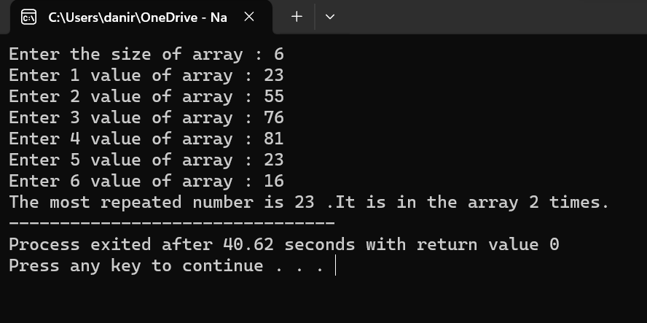

**TASK 2**

#include <bits/stdc++.h>

using namespace std;

int main()

{

int a[8] = {13, 15, 17, 9, 99, 77, 65, 43} ;

int largest = a[0] , smallest = a[0];

for(int i=1 ; i<8 ; ++i){

if(a[i] < smallest){

smallest = a[i];

}

if(a[i] > largest){

largest = a[i];

}

}

cout<<"The largest value in this array is "<<largest<<endl;

cout<<"The smallest value in the array is "<<smallest;

return 0;

}

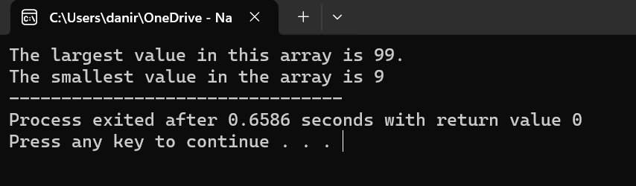

**TASK 3**

#include <bits/stdc++.h>

using namespace std;

int main()

{

int arr[5];

int temp;

cout<<"Enter the values in array : \n";

for(int i=0 ; i<5 ; ++i){

cin>>arr[i];

}

cout<<"Before swapping :"<<endl;

for(int j=0 ; j<5 ; ++j){

cout<<arr[j]<<"\t";

}

cout<<endl;

temp = arr[2];

arr[2] = arr[4];

arr[4] = temp;

cout<<"After swapping :"<<endl;

for(int k=0 ; k<5 ; ++k){

cout<<arr[k]<<"\t";

}

return 0;

}

